**DOCKER IMAGES**

**What is Docker file:**

Docker can build images automatically by reading the instructions from a file called Dockerfile

**HOW TO CREATE DOCKER IMAGES :**

>>at a time if you want to use two commands,

$ ls ,, hostname

We can create Docker image by writing the Docker file and we can create image from containers

**HOW TO CREATE DOCKER FILE:**

>>First we have to create one file, file name must be Docker file in this file we will write group of commands.

>>Docker file is nothing but group of commands or text files

Like,

**FROM 🡪What should be base image**

**RUN 🡪 If you want to run any linux commands you should declare before RUN**

**CMD 🡪 It is a default command of container**

**ADD 🡪 The files you want to copy into the container from host**

**COPY 🡪 The files you want to copy into the container from host**

**WORKDIR 🡪 It is define a workspace where upcoming or following set of commands /intructions should be execute**

**EXPOSE 🡪 Do you want your image or application should be run with 8080 port number then we have to give port number like EXPOSE 8080**

>>when we build the docket file one image will be created, to create Docker image first we need to write Docker file and we have to build that Docker file the command is , **$Docker build**

>>when we build the Docker file based on the commands one new image will be created after that we can create multiple containers from the Docker image.

**HOW TO CREATE OWN IMAGE:**

in server i am creating one directory

$mkdir ubuntu

$cd ubuntu

-->now i am creating one docker file

$vi dockerfile

**FROM ubuntu:latest**

**MAINTAINER devops2018 ,devopstraining2015@gmail.com**

**RUN yum update -y**

$docker build

$docker images

$docker run -it image-id or image -name

$cd opt

$ls

**FROM ubuntu:latest** ------------FROM is nothing but from where what should be base image like centos or ubuntu for this purpose we are writing FROM

**MAINTAINER devops2018 ,devopstraining2015@gmail.com** ---------- MAINTAINER is nothing but who is maintaining your image that maintainer username and maili d we have to give.

**RUN yum update -y** ---------- if you want to pass any commands that commands in RUN section example , RUN yum install git -y or if i want to update my yum repository then

**RUN yum update -y**

**EXAMPLE :**

Now i written docker file ,

**$ vi dockerfile**

**FROM ubuntu:latest**

**MAINTAINER devops2018 ,devopstraining2015@gmail.com**

**RUN yum update -y**

**$ docker build**

this is my docker file now i want to create docker image so that we have to hit a command is **$docker build**

>>to create docker image from docker file the command is **$docker build**

>>to create image from container the command is **$docker commit container-id**

**------------------------------------------------------------------------------------------------------**

>>in docker file we can write anything like installing git or softwares or

creating directories or files this and all we can write in docker file after that once we hit a docker build command whaterver software we written and what are the files we written inside the docker file everything will be installed and created one docker image.

**ANOTHER DOCKER FILE :**

$vi dockerfile

**FROM ubuntu:latest**

**MAINTAINER devops2018 ,devopstraining2015@gmail.com**

**RUN yum update -y**

**RUN yum install -y httpd**

$ docker build

--------------------------------------------------------------------------------------------------------

ANOTHER FILE :

**FROM ubuntu:latest**

**MAINTAINER devops2018 ,devopstraining2015@gmail.com**

**RUN yum update -y**

**RUN cd/opt ' ' touch file1**

**:wq!**

**---------------------------------------------------------------------------------------------------------------**

**FROM ubuntu:latest**

**MAINTAINER devops2018 ,devopstraining2015@gmail.com**

**RUN yum update -y**

**RUN yum install -y httpd git wget**

**RUN mkdir /opt/mvn**

**RUN cd /opt/mvn ' ' wget (path of the s/w (maven)) ------to download s/w**

**RUN cd /opt/mvn ' ' tar -xvf filename(mvn filename) ----to extract tar file**

**RUN cd /opt ' ' touch file1**

**:wq!**

**---------------------------------------------------------------------------------------------------------------**

**>>Suppose if you want to set Environment variables ,To set environment variables we have to set a pass ENV**

**EXAMPLE :**

**FROM ubuntu:latest**

**MAINTAINER devops2018 ,devopstraining2015@gmail.com**

**RUN yum update -y**

**RUN yum install -y httpd git wget**

**RUN cd /opt ' ' touch file1**

**RUN mkdir /opt/mvn**

**RUN cd /opt/mvn ' ' wget (path of the s/w (maven)) ------to download s/w**

**RUN cd /opt/mvn ' ' tar -xvf filename(mvn filename) ----to extract tar file**

**ENV M2_HOME=/opt/mvn/**

**RUN echo "text file" > /opt/test1 --------- here i am creating text file in /opt/test1**

**:wq!**

**---------------------------------------------------------------------------------------------------------------**

**DOCKER INSPECT :**

if you hit a command $docker inspect container-id >> it will display all information about that conatiner. it will dispaly like file , Now if i want to search particular file then i have to use grep command

Example :

$docker inspect container-id | grep IPA ---------->it will display IP address

**CMD and ENTRYPOINT:**

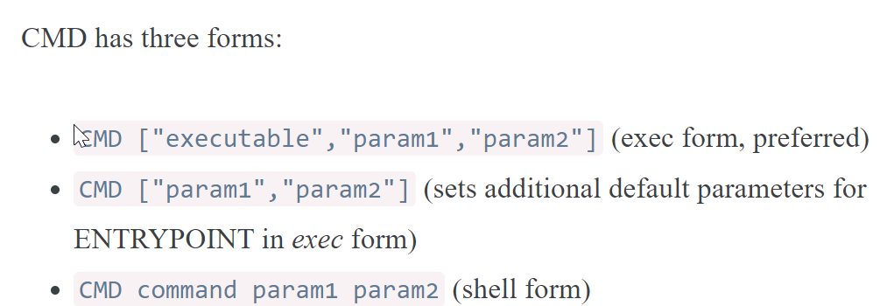

ENTRYPOINT also same as CMD

**ENTRYPOINT:**

* ENTRYPOINT instructions allows you to configure a container that will run as an executable, It looks similar to CMD

ENTRYPOINT has two forms:

* ENTRYPOINT ["executable", "param1", "param2"] (exec form, preferred)
* ENTRYPOINT command param1 param2 (shell form)

